Week 02

Question 1:

Many people think about their height in feet and inches, even in some countries that  primarily use the metric system. Write a program that reads a number of feet from the  user, followed by a number of inches. Once these values are read, your program should compute and display the equivalent number of centimeters.

**Hint**: One foot is 12 inches. One inch is 2.54 centimeters.

**Input Format**

First line, read the number of feet.

Second line, read the number of inches.

**Output Format**

In one line print the height in centimeters.

Note: All of the values should be displayed using two decimal places.

**Sample Input 1**

5

6

**Sample Output 1**

167.64

Program:

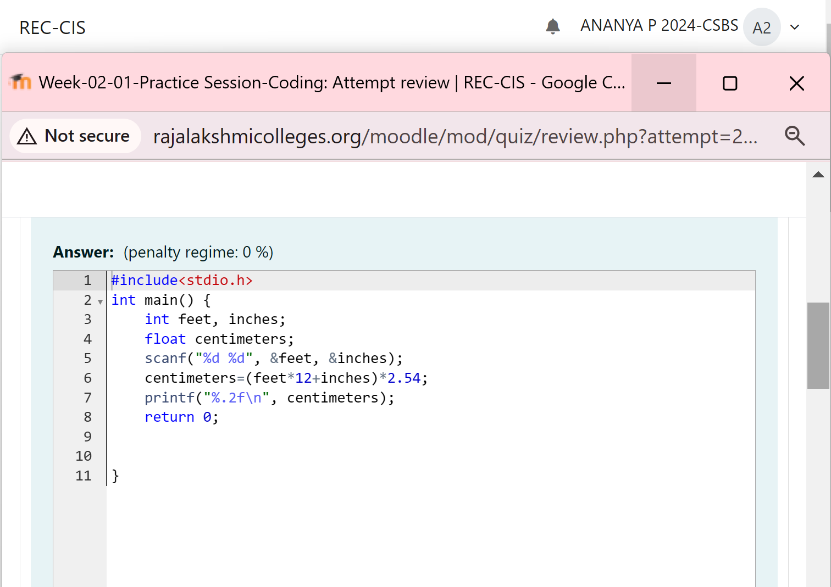

Output:

Question 2:

Create a program that reads two integers, a and b, from the user. Your program should  compute and display:

• The sum of a and b

• The difference when b is subtracted from a

• The product of a and b

• The quotient when a is divided by b

• The remainder when a is divided by b

**Input Format**

First line, read the first number.

Second line, read the second number.

**Output Format**

First line, print the sum of a and b

Second line, print the difference when b is subtracted from a

Third line, print the product of a and b

Fourth line, print the quotient when a is divided by b

Fifth line, print the remainder when a is divided by b

**Sample Input 1**

100

6

**Sample Output1**

106

94

600

16

4

Program:

Output:

Question 3:

Program:

Output:

Question 4:

Goki recently had a breakup, so he wants to have some more friends in his life. Goki has  **N** people who he can be friends with, so he decides to choose among them according to  their skills set **Yi**(1<=i<=n). He wants atleast **X** skills in his friends.

Help Goki find his friends.

**Input Format**

First line contains a single integer **X** - denoting the minimum skill required to be Goki's  friend. Next line contains one integer **Y** - denoting the skill of the person.

**Output Format**

Print if he can be friend with Goki. '**YES' (without quotes)** if he can be friends with Goki  else '**NO' (without quotes)**.

**Constraints**

**1<=N<=1000000 1<=X,Y<=1000000**

**SAMPLE INPUT 1**

100

110

**SAMPLE OUTPUT 1**

YES

Program:

Output:

Question 5:

Before the outbreak of corona virus to the world, a meeting happened in a room in Wuhan.  A person who attended that meeting had COVID-19 and no one in the room knew about it!  So, everyone started shaking hands with everyone else in the room as a gesture of respect  and after meeting unfortunately everyone got infected! Given the fact that any two persons  shake hand exactly once, can you tell the total count of handshakes happened in that  meeting?

***Say no to shakehands. Regularly wash your hands. Stay Safe.***

**Input Format**

Read an integer N, the total number of people attended that meeting.

**Output Format**

Print the number of handshakes.

**Constraints**

0 < N < 106

**SAMPLE INPUT 1**

1

**SAMPLE OUTPUT**

0

Program:

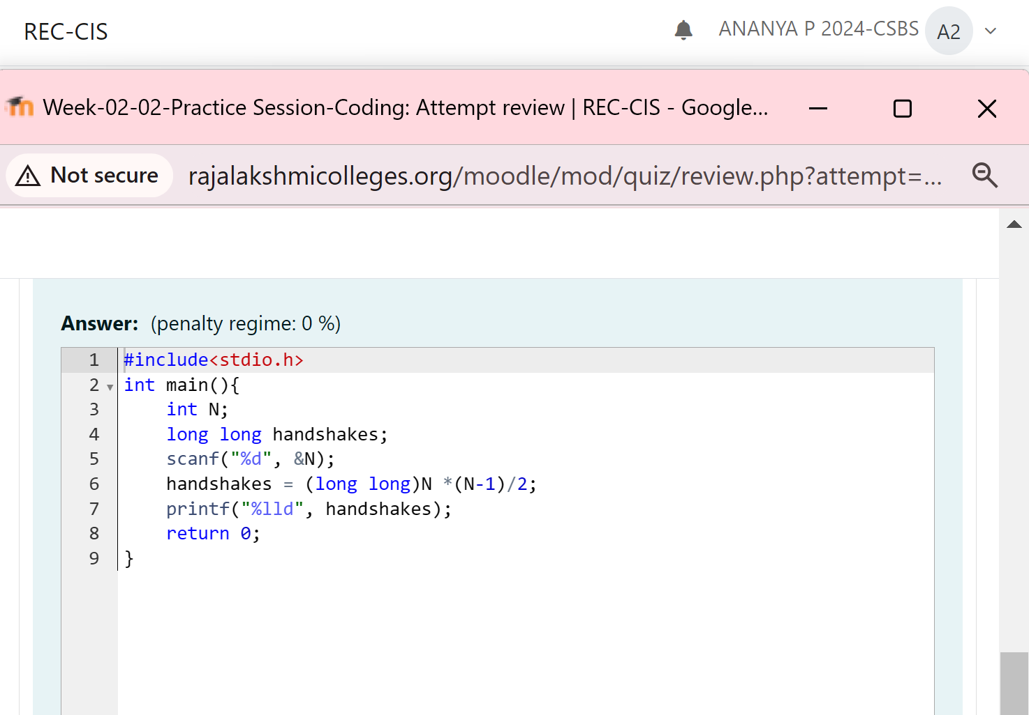

Output:

Question 6:  
In our school days, all of us have enjoyed the Games period. Raghav loves to play cricket  and is Captain of his team. He always wanted to win all cricket matches. But only one last  Games period is left in school now. After that he will pass out from school.

So, this match is very important to him. He does not want to lose it. So he has done a lot of  planning to make sure his teams wins. He is worried about only one opponent - Jatin, who  is very good batsman.

Raghav has figured out 3 types of bowling techniques, that could be most beneficial for  dismissing Jatin. He has given points to each of the 3 techniques.

You need to tell him which is the maximum point value, so that Raghav can select best  technique.

3 numbers are given in input. Output the maximum of these numbers.

**Input Format:**

Three space separated integers.

**Output Format:**

Maximum integer value

**SAMPLE INPUT**

8 6 1

**SAMPLE OUTPUT**

8

Program:

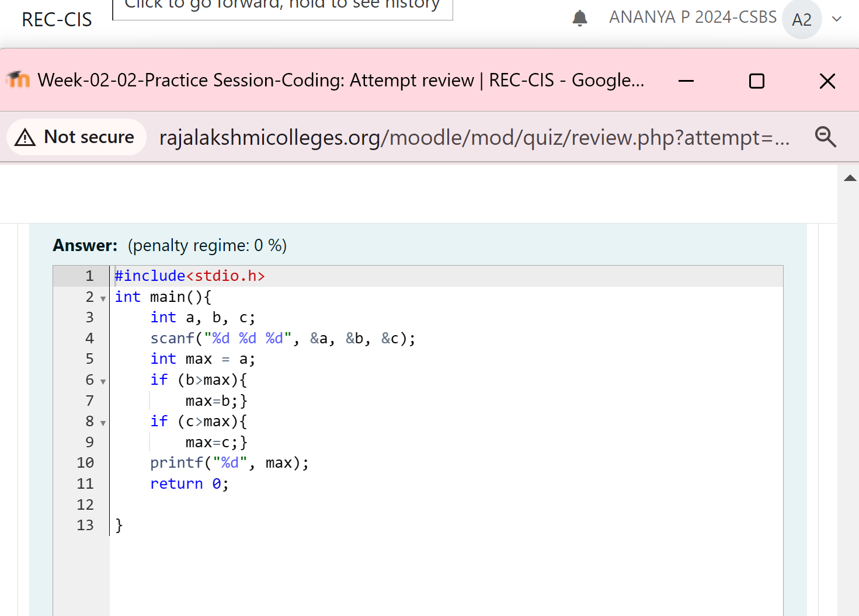

Output:

